O MANTRA DOS MANTRAS
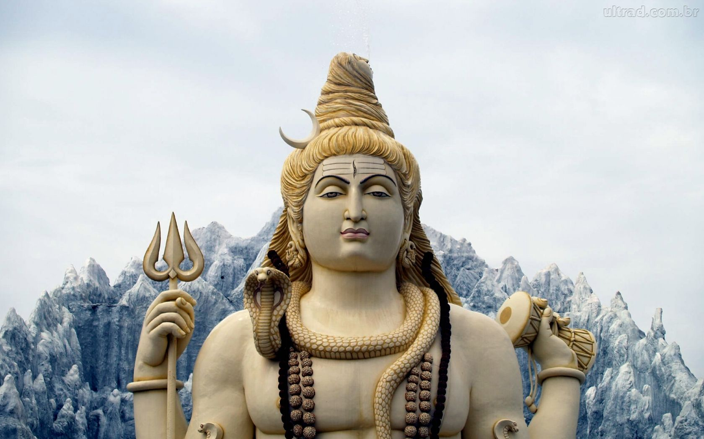
<> <> <>
OM SRI SAI SARVA KUNDALINI ANTAKARANA DHANVANTRE SHIVAYA NAMAHA
OM SRI SAI SARVA KUNDALINI ANTAKARANA DHANVANTRE SHIVAYA NAMAHA
OM SRI SAI SARVA KUNDALINI ANTAKARANA DHANVANTRE SHIVAYA NAMAHA

